http://blog.51cto.com/12800032/2061257
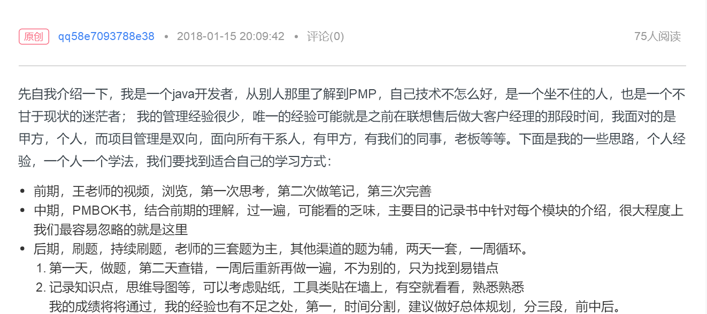
http://blog.51cto.com/9537343/2061075
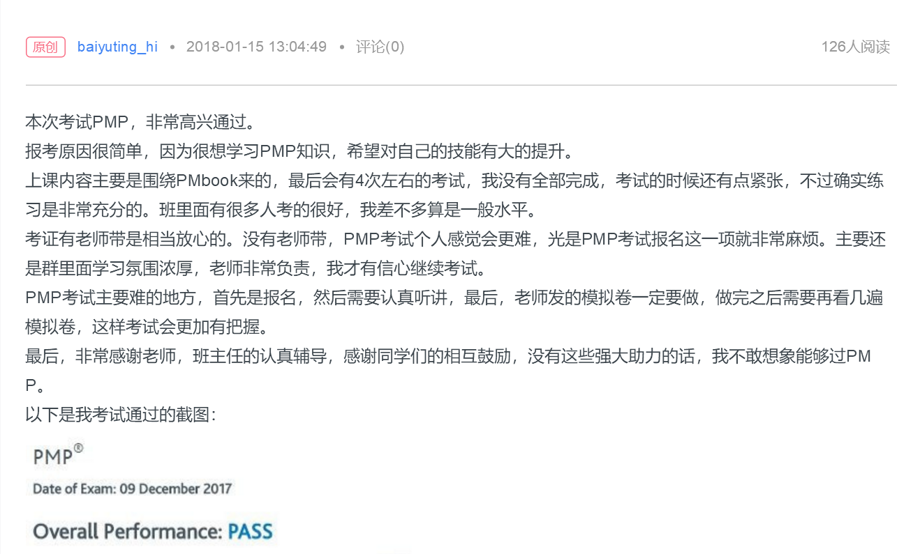

http://blog.51cto.com/13355947/2061108
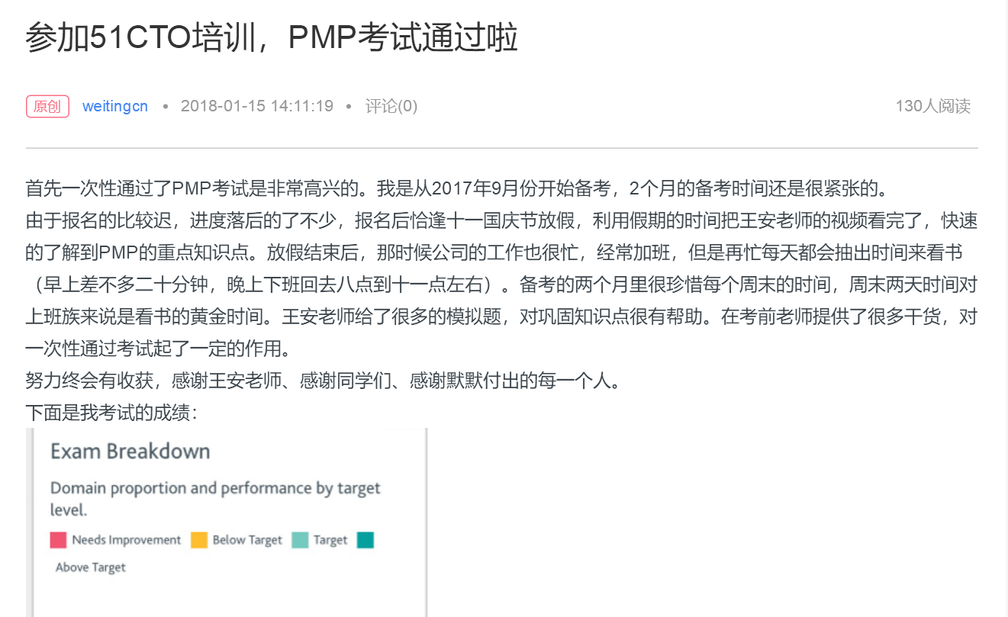

http://blog.51cto.com/4250022/2061034
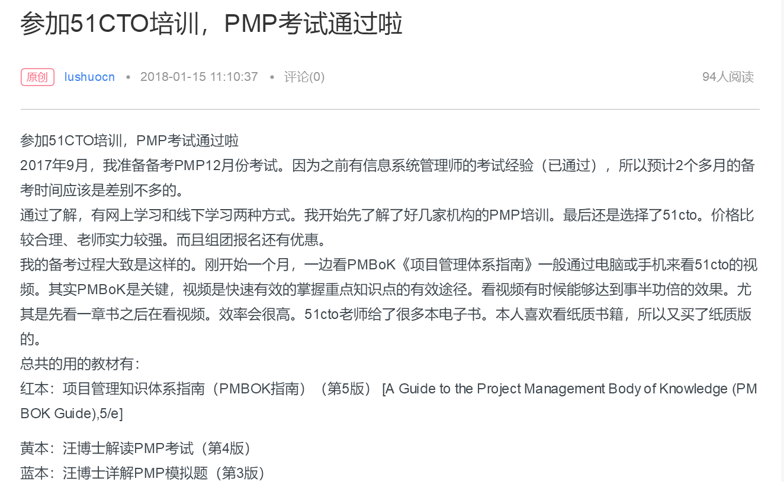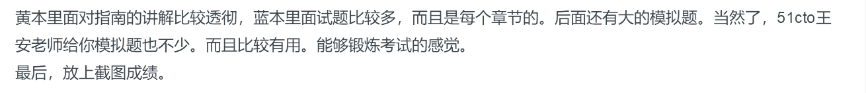

http://blog.51cto.com/13106448/2061039
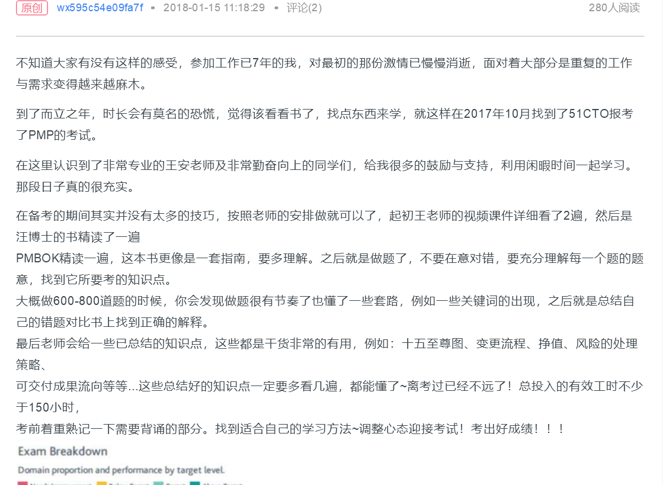

http://blog.51cto.com/1523735/2061122
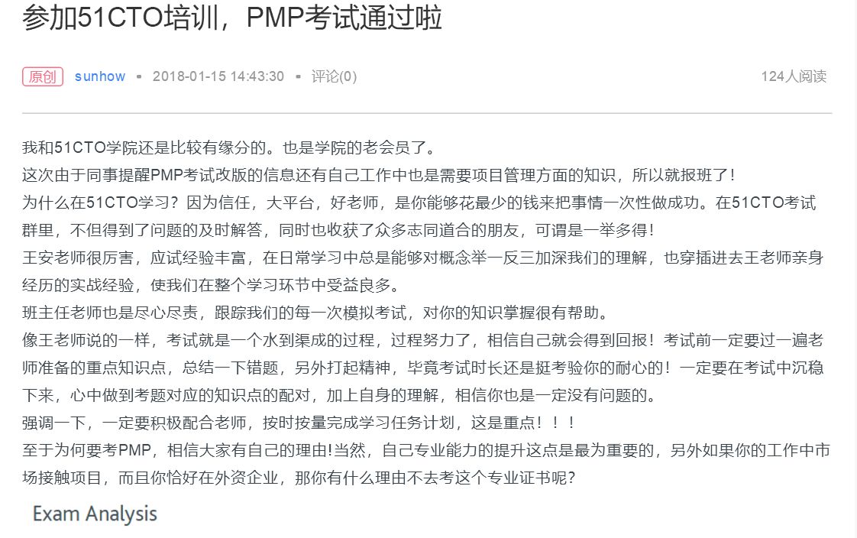

http://blog.51cto.com/1202736/2061066
